AI Assignment Report

**Discussion of relative merits of search strategies**

Advantages of BFS:-

1. Solution will definitely found out by BFS If there are some solution.

2. BFS will never get trapped in blind alley , means unwanted nodes.

3. If there are more than one solution then it will find solution with minimal steps.

Disadvantages Of BFS :-

1. Memory Constraints As it stores all the nodes of present level to go for next level.

2. If solution is far away then it consumes time.

Advantages Of DFS :-

1. Memory requirement is Linear WRT Nodes.

2. Less time and space complexity rather than BFS.

3. Solution can be found out by without much more search.

Disadvantage of DFS :-

1. Not Guaranteed that it will give you solution.

2. Cut-off depth is smaller so time complexity is more.

3. Determination of depth until the search has proceeds.

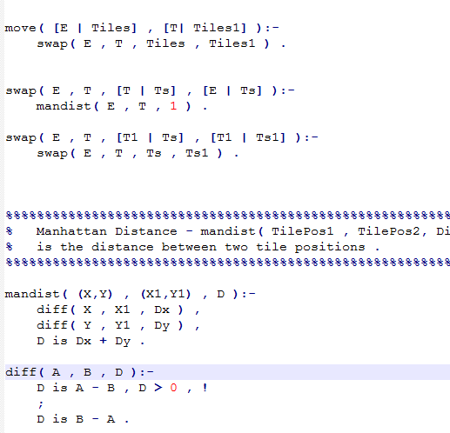

this code is to find which cell can swap with null cell. D is distance between cell and null cell, if distance is 1 then they can swap if not they can not swap.

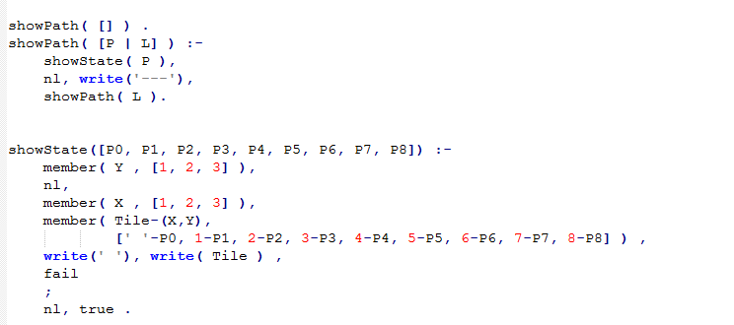

This code is shows each step of swap of cells.

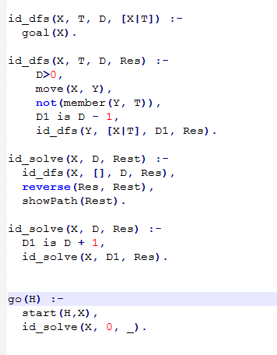

This code is to find solution of each depth, if no solution go next depth or go back last depth to find next, until find the goal.



After implement, the result shows.